PROJECT OVERVIEW

Making fault tolerant distributed applications is a difficult task. There are many issues that an application designer must consider when attempting to provide fault tolerance. Some of the issues a developer seeking to create a fault-tolerant (FT) application must consider include: selecting the degree of replication, selecting a fault model, and protocol design. Specifically, the objective of our project was to build distributed fault-tolerant applications based on JavaRMI and CORBA.
Our project is focused on fault tolerance through active replication of components: applications that are instantiated simultaneously over several hosts, to offer high availability. Its domain is CORBA and JavaRMI applications that have strict fault tolerance requirements.

This project defines the following subsystems:

- GMS: This subsystem provides the functionality to make reliable group communications, that is, all or none of the members in the group receive the messages. In addition, the subsystem uses total order algorithms to guarantee that every member in the group receives the same set of messages in exactly the same order.
These features are the basics of the Virtual Synchrony Model: if the members of the group are replicas of the same object and they share the same initial state, as they process the same sequence of messages, they will share the same final state, keeping therefore the consistency.

- Domains: this layer is built on top of GMS, providing tools and a framework to simplify the development of replicated applications. Its main feature is the definition of components as the replication unit, facilitating the use of those replicated components in the application. The components are shared by the application replicas, requesting therefore support for concurrent access and transactions, both provided by the framework. Using the replicated components, and the given support, it is possible to design replicated applications as if they were just multithread.

GMS and Domains are implemented in Java, offering the same interface to CORBA and JavaRMI applications. Together with these subsystems, there is an additional one covering the directory services. This last subsystem is called GMNS (GMNS = group membership naming service), and it's itself a replicated application, developed on top of Domains and making use of its components strategy: it is, therefore, a proof of concept of the developed methodology.

Following is a picture showing the subsystems and their interactions;

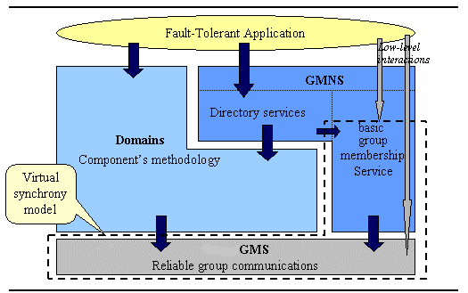

PROJECT SPECIFICATIONS

Hardware Environment:-

For any System to be Successful, it requires a proper Hardware Environment. Hardware is the most basic and important thing to be considered for developing a System. Before developing a System, the Hardware Requirements for the development of the environment should be pre - planned.

Minimum Requirement:

- Processor Pentium III
- RAM 64 MB
- Hard disk 2 GB or more.

Recommended Hardware:

- PENTIUM III Processor, 733 MHz.
- 128 MB RAM or above.
- 5 GB Hard Disk and above.

Hardware Used:

PENTIUM III Processor, 1.1 GHz

128 MB RAM.

20 GB Hard Disk.

Software Environment

To develop any System or Project, both Hardware and Software are required. Before developing a system, proper planning and decision about the Software Environment should be made. Also some Software may not be platform-Independent and can run only on specific Operating Systems.

According to the given Problem statement, the System Analysis should decide the proper hardware and Software Environment for developing a Successful solution System.

Operating system: -

As this project is built on Java, it will run on any machine witch a Java Virtual Machine. It has been tested on the next configurations:

- Red Hat Linux 7.3 / JDK 1.4 (JDK orb)
- Windows 2000 / JDK 1.4, using JDK orb
- Windows XP/ JDK 1.4, using JDK orb

Software Used: -

- J2SDK1.4
- ANT
- CORBA 2.4 compliant ORB (JDK1.4)
.

TECHNOLOGY

RMI (Java Remote Method Invocation)

The Java Distributed Object Model
The distributed object model used by Java allows objects that execute in one JVM to invoke the methods of objects that execute in other JVMs. These other JVMs may execute as a separate process on the same computer or on other remote computers. The object making the method invocation is referred to as the client object. The object whose methods are being invoked is referred to as the server object. The client object is also referred to as the local object and is said to execute locally. The server object is also referred to as the remote object and is said to execute remotely.
In the Java distributed object model, a client object never references a remote object directly. Instead, it references a remote interface that is implemented by the remote object. The use of remote interfaces allows server objects to differentiate between their local and remote interfaces. For example, an object could provide methods to objects that execute within the same JVM that are in addition to those that it provides via its remote interface. The use of remote interfaces also allows server objects to present different remote access modes. For example, a server object can provide both a remote administration interface and a remote user interface. Finally, the use of remote interfaces allows the server object's position within its class hierarchy to be abstracted away from the manner in which it is used. This allows client objects to be compiled using the remote interface alone, eliminating the need for server class files to be locally present during the compilation process.

The Three-Tiered Layering of the Java RMI
In addition to remote interfaces, the model makes use of stub and skeleton classes in much the same way as CORBA. Stub classes serve as local proxies for the remote objects. Skeleton classes act as remote proxies. Both stub and skeleton classes implement the remote interface of the server object. The client interface invokes the methods of the local stub object. The local stub communicates these method invocations to the remote skeleton, and the remote skeleton invokes the methods of the server object. The server object returns a value to the skeleton object. The skeleton object returns the value to the stub object, and the stub object returns the value to the client.

Figure below illustrates the three-tier layering used to implement Java RMI. In this expanded view of the model, the client object invokes the methods of the local stub of the server object. The local stub uses the remote reference layer to communicate with the server skeleton. The remote reference layer uses the transport layer to set up a connection between the local and remote address spaces and to obtain a reference to the skeleton object.

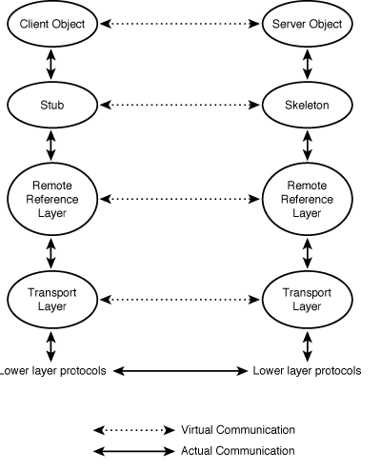
The three-tier layering of Java RMI.

In order for a server object to be accessed remotely, it must register itself with the remote registry. It does this by associating its object instance with a name. The remote registry is a process that runs on the server host, and is created by running the rmiregistry program, another JDK tool.
The remote registry maintains a database of server objects and the names by which these objects can be referenced. When a client creates an instance of a server object's interface (that is, its local stub), the transport layer on the local host communicates with the transport layer on the remote host to determine if the referenced object exists and to find out type of interface the referenced object implements. The server-side transport layer uses the remote registry to access this information. A separate process, referred to as the Java RMI Activation System Daemon, supports the activation of remote objects.

Objects and Remote Method Invocation
The Java distributed object model is a natural extension of the Java object model used within a single JVM. It implements RMI in an easy-to-use fashion and places minimal requirements on objects in order for them to be accessed remotely. These requirements are as follows:
- The object's class must implement an interface that extends the Remote interface. This interface must define the methods that the object will allow to be remotely invoked. These methods must throw RemoteException.
- The object's class must extend the RemoteServer class. This is typically done by extending the UnicastRemoteObject subclass of RemoteServer.
- The stub and skeleton classes of the object's class must be created using the rmic compiler. The stub must be distributed to the client host.
- The remote object's class, interface, and skeleton class must be in the CLASSPATH of the remote host.
- The remote activation daemon and remote registry must be started.
- A remote object instance must be created and registered with the remote registry. The bind() and rebind() methods of the Naming class are used to register an object with its associated name. The remote object should install a security manager to enable loading of RMI classes.

CORBA

Why CORBA?
Distributed systems rely on the definition of interfaces between components and on the existence of various services (such as directory registration and lookup) available to an application. CORBA provides a standard mechanism for defining the interfaces between components as well as some tools to facilitate the implementation of those interfaces using the developer's choice of languages. In addition, the Object Management Group (the organization responsible for standardizing and promoting CORBA) specifies a wealth of standard services, such as directory and naming services, persistent object services, and transaction services. Each of these services is defined in a CORBA-compliant manner, so they are available to all CORBA applications. Finally, CORBA provides all the "plumbing" that allows various components of an application--or of separate applications--to communicate with each other.

CORBA Architecture Overview
First of all, CORBA is an object-oriented architecture. CORBA objects exhibit many features and traits of other object-oriented systems, including interface inheritance and polymorphism. What makes CORBA even more interesting is that it provides this capability even when used with nonobject-oriented languages such as C and COBOL, although CORBA maps particularly well to object-oriented languages like C++ and Java.

The Object Request Broker (ORB)
Fundamental to the Common Object Request Broker Architecture is the Object Request Broker, or ORB. An ORB is a software component whose purpose is to facilitate communication between objects. It does so by providing a number of capabilities, one of which is to locate a remote object, given an object reference. Another service provided by the ORB is the marshaling of parameters and return values to and from remote method invocations. CORBA is the standard that implements ORB capability. The use of ORBs provides platform independence to distributed CORBA objects.

Interface Definition Language (IDL)
Another fundamental piece of the CORBA architecture is the use of the Interface Definition Language (IDL). IDL, which specifies interfaces between CORBA objects, is instrumental in ensuring CORBA's language independence. Because interfaces described in IDL can be mapped to any programming language, CORBA applications and components are thus independent of the language(s) used to implement them. In other words, a client written in C++ can communicate with a server written in Java, which in turn can communicate with another server written in COBOL, and so forth.
One important thing to remember about IDL is that it is not an implementation language. That is, you can't write applications in IDL. The sole purpose of IDL is to define interfaces; providing implementations for these interfaces is performed using some other language.

The CORBA Communications Model
CORBA uses the notion of object references (which in CORBA/IIOP lingo are referred to as Interoperable Object References, or IORs) to facilitate the communication between objects. When a component of an application wants to access a CORBA object, it first obtains an IOR for that object. Using the IOR, the component (called a client of that object) can then invoke methods on the object (called the server in this instance).
In CORBA, a client is simply any application that uses the services of a CORBA object; that is, an application that invokes a method or methods on other objects. Likewise, a server is an application that creates CORBA objects and makes the services provided by those objects available to other applications.
CORBA ORBs usually communicate using the Internet Inter-ORB Protocol (IIOP). Other protocols for inter-ORB communication exist, but IIOP is fast becoming the most popular, first of all because it is the standard, and second because of the popularity of TCP/IP (the networking protocols used by the Internet), a layer that IIOP sits on top of. CORBA is independent of networking protocols, however, and could run over any type of network protocols. For example, there are also implementations of CORBA that run over DCE rather than over TCP/IP, and there is also interest in running CORBA over ATM and SS7.

PROJECT DETAILS

GMS
GMS stands for GroupMembershipService, the core concept on the Virtual Synchrony model. Using this model, members sharing a common interface can become part of a group; In this group, any member can send a message to all of the group members (multicast), with total reliability: or every group member receives the message, or none does. In addition, every member observes the same sequence of messages (same order); as a result, as far as they share a common initial state, they evolve to the same final state.
GMS is a CORBA and JavaRMI interface, both sharing the same functionality, which an application can directly use. Using GMS, the application can be made fault tolerant, by running several instances on different hosts. Each time an instance is going to change its state due to a client interaction; it must send a multicast message to the group of instances: every instance observes therefore the same sequence of changes, evolving therefore to the same final state. If any of the instances falls down, any other of the replicas can still serve client requests, achieving the required fault tolerance.
The GMS interface supports:
- To send reliable multicast messages to the group of replicas. It is guaranteed that all the replicas observe the same messages on the same order.
- To send point to point messages to other replica in the group. The order with respect to the multicast messages is also guaranteed.
- The delivery of events to the group members; these events are the group messages, but also the changes on the group composition.

GMS achieve reliable group communications and total ordering by means of a logical ring, constituted by the group replicas, where a token is transferred from replica to replica. Only the replica owning the token is able to communicate with the group; the exception to this rule is when a replica suspects that the token is lost, and must therefore initiate talks to the other members in order to recreate the token. The list of non-faulty members in a group, called view, which is transmitted to every group member, is maintained by this internal service called GMS.
Replicas must implement the interface GroupMember, and they can join/leave a group or send reliable multicast communication to other replicas using the interface GroupHandler. During their lifetime in the group, members receive views, structures containing information about group composition. Messages sent between members must be defined by the application; using RMI, messages are defined as java.util.Serializable instances, while in CORBA messages are defined as valuetypes; in this way, inheritance is allowed and the access is local on each replica that receives the message. Nevertheless, it is not mandatory to use typed messages; generic non-typed messages can be used as well.

Algorithms
GMS achieve reliable group communications and total ordering by means of a logical ring, constituted by the group replicas, where a token is transferred from replica to replica. Only the replica owning the token is able to communicate with the group; the exception to this rule is when a replica suspects that the token is lost, and must therefore initiate talks to the other members in order to recreate the token.
This algorithm is quite simple, its only difficulty is to ensure that the token is not lost or duplicated.
The implementation of the algorithm has been carefully done to obtain a good performance on the group communications.
The idea of the token and the ring is not new, as has been already used if other group communication systems. The main difference of our implementation is that it is implemented on top of point-to-point communications, instead of unreliable multicast (UDP).

Public interface
There are five important types in the interface. The three basic ones are:
- Members identities: each member has a unique identity inside the group, defined with the type GroupMemberId.
- Messages: the type of communication used between members. It is defined with the type Message, being the application usually responsible to define their own specific messages, by inheritance from the specific type.
- Views: a view is the composition of the group on a given moment. Basically, it includes the list of members (of member identities), and an id. Whenever the group's composition changes, every member receives an event with the new view, and it is guaranteed that every member receives the same sequence of views.

In OMG/IDL, these types are:
typedef long GroupMemberId;
typedef sequence <GroupMemberId> GroupMemberIdList;
struct View
{
long viewId;
GroupMemberIdList members;
GroupMemberIdList newMembers;
GroupMemberIdList expulsedMembers;
};
valuetype Message {};
Using JavaRMI, the GroupMemberId is defined as an int, being the other two types:
final public class View implements java.io.Serializable
{
public int viewId;
public int[] members;
public int[] newMembers;
public int[] expulsedMembers;
}

public abstract class Message implements java.io.Serializable { }

An application must create an object that inherits from GroupMember to be able to join a group. This interface is used by GMS to send events to the application, and is defined in IDL as:
interface GroupMember
{
void processPTPMessage(in GroupMemberId sender, in Message msg);
void processCastMessage(in GroupMemberId sender, in Message msg);
void memberAccepted(in GroupMemberId identity, in GroupHandler handler, in View theView);
void changingView();
void installView(in View theView);
void excludedFromGroup();
};
When a member requests to join a group, it receives eventually an event memberAccepted, which contains its member identity and the group's composition, and an object of type GroupHandler, which is the gateway of this member to establish communications with the group:
interface GroupHandler
{
boolean castMessage(in Message msg);
boolean sendMessage(in GroupMemberId target, in Message msg);
boolean leaveGroup();
GroupMemberId getGroupMemberId();
boolean isValidGroup();
};
These interfaces are, in JavaRMI, completely equivalent:

public interface GroupHandler extends java.rmi.Remote
{
public boolean castMessage(Message message)
throws RemoteException;
public boolean sendMessage(int target, Message message)
throws RemoteException;
public boolean leaveGroup()
throws RemoteException;
public int getGroupMemberId()
throws RemoteException;
public boolean isValidGroup()
throws RemoteException;
}

public interface GroupMember extends java.rmi.Remote
{
public void processPTPMessage(int sender, Message message)
throws RemoteException;
public void processCastMessage(int sender, Message message)
throws RemoteException;
public void memberAccepted(int identity, GroupHandler handler, View view)
throws RemoteException;
public void changingView()
throws RemoteException;
public void installView(View view)
throws RemoteException;
public void excludedFromGroup()
throws RemoteException;
}
Note that these interfaces do not show how a member can create or join a group. This functionality is implemented in GMNS (GMNS includes both, a directory service and basic functionality to create or expand groups). There is not obscurity here: GMS has a public interface, shown already, and a private interface, used to pass the token, recover it, send messages and so on: this private interface defines operations to join the group, but we have opted to make this operation public only at the GMNS level.

The basic definition of these interfaces using CORBA IDL is the following:

typedef long GroupMemberId;
valuetype Message {};
interface GroupHandler
{
GroupMemberId getGroupMemberId();
boolean isValidGroup();
boolean leaveGroup();
boolean castMessage(in Message msg);
boolean sendMessage(in GroupMemberId target,
in Message msg);
};

interface GroupMember
{
void processPTPMessage(in GroupMemberId sender,
in Message msg);

void processCastMessage(in GroupMemberId sender,
in Message msg);
void memberAccepted(in GroupMemberId identity,
in GroupHandler handler,
in View theView);
void changingView();
void installView(in View theView);
void excludedFromGroup();
};

A replicated server defines its IDL or Java interface inherited from GroupMember; for example, a simple replica that generates sequential numbers can be specified in Java as:

interface NumberGenerator extends GroupMember
{
public int getNumber() throws RemoteException;
};
If this replica requires a message to be sent containing the last generated number, it could define a message that in CORBA would be:

valuetype NumberGeneratorMessage : Message
{
public long number;
};

Using GMS
The simplest example is the RandomCounter, containing the following files:
- RandomCounter.idl (in CORBA) or RandomCounterMessage.java and RandomCounterServer.java (in JavaRMI): define the internal messages in the group, and the specification of the server.
- Client.java: the implementation of the client, which access the GMNS server to obtain a reference to the server.
- Server.java: the implementation of the server, which must use the group communications supported in FTDA.
- Main.java: common main method for both the client and the server, it performs some common initialization
- SetNumbers.java: helper class, it implements the real logic of the server (returning always a different random number), but without any replication or group communication

DOMAINS
Domains is a subsystem built on top of GMS, providing a methodology to simplify to a very high degree the development of replicated applications.
Its main feature is the support of replicated components:
- Supports static or dynamic components, being dynamics those created at runtime, providing Domains the logic to automatically instantiate the component on the replicated instances.
- Concurrency mechanisms that allow the application to use the replicated components as normal ones on a multithread environment.
- Support of transactions, to avoid inconsistencies in case that a replica falls down while updating multiple components.
Besides this, FTDA supports as well flexible state transfer mechanisms. Domains defines as well tools to automatically replicate an application; this mechanisms are similar to the model employed in the CORBA fault tolerant service, and they share therefore most of the inconvenient.
The IDL interfaces of Domains are:
- DomainExceptions.idl. Defines the generic exceptions handled by Domains (some specific exceptions are defined in the other idl files.
- StateTransfer.idl. Defines all the types related to the state transfer.
- Properties.idl. Specifies the types associated to the properties and properties handler.
- SubgroupsHandler.idl. This file defines the types needed to handle subgroups (or components).
- DomainMessage.idl. Specifies the concept of domain message.
- Concurrency.idl. Defines the concurrent mechanisms: replicated monitors and transactions.
- DomainGroupHandler.idl. Defines the concept of domain. It depends on all the previous files.
In addition, the file InternalDomainMessages.idl. defines the messages and other types used internally by Domains (do not belong, therefore, to the public interface).
Using RMI, the definition is totally equivalent. The files that compose this interface are included in the package FTDA.middleware.domains under the rmi structure.

GMNS
GMNS stands for GroupMembershipNamingService. The basic subsystem does not define public operations to create or extend groups. This functionality is shifted to this subsystem, being implemented in two different ways:
- Basic service: defines two operations, create and join.
In case of using join, the client must supply a reference to a member in the group to join.
- Naming service: the GMNS associates names to groups, and the client must only specify the name of the group to use: the GMNS server creates a group or extends it if already present.
Although the naming service is more appealing, it involves much more effort. A specific application, the GMNS server, must be running; and, to achieve fault tolerance, this server must be itself replicated; the user should specify the right configuration values in order to use it properly.

Basic service
The basic service is implemented through the interface GroupMembershipBasicService, defined as:
interface GroupMembershipBasicService
{
GroupHandlerFactoryCreator getFactoryCreator();
GroupHandler createGroup(in GroupHandlerFactory theFactory)
raises (InvalidGroupHandlerFactoryException,
GroupHandlerFactoryException);
GroupHandler joinGroup(in GroupHandler group,
in GroupHandlerFactory theFactory)
raises ( InvalidGroupHandlerException,
InvalidGroupHandlerFactoryException,
GroupHandlerFactoryException);
};
When a group is joined or created, a GroupHandler is returned to the client. This interface includes two new types: GroupHandlerFactory and GroupHandlerFactoryCreator.
The GroupHandlerFactory follows the factory pattern, being responsible to create new GroupHandler objects:
interface GroupHandlerFactory
{
GroupHandler create() raises (GroupHandlerFactoryException);
};
The objective of this type is to be able to create the GroupHandler object in the client's machine. Why is this needed? An application's instance, implementing the GroupMember interface, communicates with its group through a GroupHandler object. As the goal is to have fault tolerance, this GroupHandler object should reside on the same machine (and process) as the associated GroupMember. For this reason, the GMNS, that can be hosted on a different machine, is not responsible to create itself the GroupHandler, it delegates this functionality to a GroupHandlerFactory, which must be supplied by the client.
To facilitate this scenario, there is as well a factory for the factory itself:
valuetype GroupHandlerFactoryCreator
{
GroupHandlerFactory create(in GroupMember member)
raises (GroupHandlerFactoryException);
};
Note that this type is defined as valuetype: it can be created on the GMNS server, then used in the client's host to create the factory itself (which is therefore created in the client's, not in the GMNS).
A normal scenario is therefore:
- Get reference to the GroupMembershipBasicService
- Request a GroupHandlerFactoryCreator to this service
- Use this GroupHandlerFactoryCreator to create, on the client, a GroupHandlerFactory associated to the application's GroupMember
- Use this GroupHandlerFactory to create or join a group, passed as parameter to the GroupMembershipBasicService
An example using this service is the TestMonitor class in the Concurrency example.

Naming service
The naming service uses the concepts of GroupHandlerFactory and GroupHandlerFactoryCreator explained for the basic service.
The interface GroupMembershipNamingService is defined as:
interface GroupMembershipNamingService
{
GroupHandlerFactoryCreator getFactoryCreator();

GroupHandler findAndJoinGroup(in string groupName,
in GroupHandlerFactory theFactory,
in string memberName,
in ReplicatedServer clientsReference)
raises (MemberStateException,
InvalidGroupHandlerFactoryException,
GroupHandlerFactoryException);

void leaveGroup(in string groupName, in GroupHandler member);

ReplicatedServersList getGroup(in string groupName)
raises (MemberStateException);

ReplicatedServer getGroupServer(in string groupName,
in string memberName)
raises(MemberStateException);

ReplicatedServer getValidGroupServer(in string groupName)
raises(MemberStateException);
};
There is just one operation to create or extend a group: findAndJoinGroup, where the group's name must be supplied.
As difference with the basic service, now the members that use the naming service can give notice of their exclusion from their groups. This notification speeds up the process, although is not strictly required: the GMNS server checks periodically the groups to verify excluded members.
This interface is also useful for clients of the group. The server can register here a interface to be used by clients, which must inherit from ReplicatedServer, an empty definition:
interface ReplicatedServer
{
};
It must be noted that every group member must implement the GroupMember interface, to receive events from the group. But these group members have usually a server role, represented by a specific interface to be used by the clients. The GMNS server registers this interface, to be returned to any client.
The GUI of the GMNS server has the following appearance:

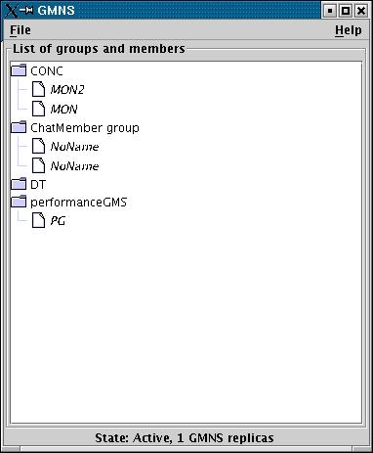
For each group, the GMNS lists the members that have been registered through the GMNS server. For these members, it shows the name used at registration time, or 'unknown' if none is given. If the member has not specified a ReplicatedServer interface (is null), the name is shown in italic, like it happens in the previous figure.

The GMNS server: execution and access
The server is executed with the script gmns.sh or gmns.bat. More information on how to execute it is found in the Example section (section scripts).
The server is usually executed as a replicated instance, that is, several instances working in a group as a single server. To do it properly, the configuration file must be carefully specified. Please refer to the Configuration section of the report.
The client must specify the same GMNS configuration data in order to access the GMNS. On a normal scenario, there is one GMNS server on each host, and therefore it is enough that the client specifies this GMNS on the configuration file. Nevertheless, to specify the whole list of possible GMNS servers can avoid problems in case that the host's server is not available.
Currently, the GMNS server does not register itself in the RMI registry or in the CORBA naming service: the reason is its replicated nature. Should it register on every possible host? Is the user going to use just one naming service in a specific host, or perhaps two for fault tolerance? What the server does is to publish its reference into a specific file or TCP/IP port, depending on the configuration values.
A Java client can use the class FTDA.gmns.GroupMembershipNamingServiceFactory to locate the service (using the same configuration values). For example, in the Random Counter example, it does:
import FTDA.gmns.GroupMembershipNamingServiceFactory;
import FTDA.middleware.gmns.GroupMembershipNamingService;

GroupMembershipNamingService service = GroupMembershipNamingServiceFactory.load();
if (service==null)
{
System.err.println("GroupMembershipNamingService is not available");
}

Implementation
The directory containing the IDL specification for the GMNS service includes some IDL files in addition to the GroupMembershipNamingService specification. These files are used on the implementation of the GMNS server.
This server is implemented on top of Domains using replicated components. The data structures must deal with:
- The server needs to keep a list of the existing groups.
- Each group must contain the list of existing members.
For each member, it is needed to store its name, reference, and client's reference (ReplicatedServer instance).
- A group is therefore identified by a name, and the list containing the existing members.
Following components are therefore required:
- MemberInfo, defined in MemberInfo.idl: contains the information related to a specific member (name and references).
This component is not replicated itself (just an struct).
- SetMemberInfo, defined in SetMemberInfo.idl: this is a replicated component, containing the list of objects MemberInfo. It is a set because the same member cannot be contained twice.
- MapStringSet, defined in MapStringSet.idl: this is as well a replicated component, a map associating strings (the group name) to SetMemberInfo components.
When a GMNS server requires adding a new group, it creates a new SetMemberInfo component, which is automatically replicated over all the instances. It must then include the member in its SetMemberInfo, but the MemberInfo object that is included is automatically sent to the other replicas, that perform the same inclusion. And finally, it associates the SetMemberInfo object with the group's name in the MapStringSet. Again, this operation is performed on every replica.
This logic must be executed with replicated monitors, to avoid concurrency problems if other replica tries to do some incompatible operation.
The main advantage on using the component's philosophy embedded in Domains is that the main logic is exactly like in a multithread application: the code is the same, including the use of monitors..
The IDL specification for GMNS includes still other file, GroupsCheckerState.idl: this file defines the checking state for every GMNS instance. The GMNS server must check periodically whether the registered instances are alive or have felt down or just excluded from their groups. But it is not needed that every replicated GMNS server performs this checking, just one. The GroupsCheckerState defines the identity of the GMNS server that is responsible for this task.
Package Arrangement
The access to FTDA and its subsystems is exclusively done through the IDL interfaces (for CORBA, in case of JavaRMI, through the remote interfaces). The interface is therefore object oriented. FTDA supports CORBA and JavaRMI, through two different interfaces. These interfaces are different because they are specified in different languages, but they're intended to support the same functionality. In fact, the implementation is the same for both cases.
To understand how is possible to share the same implementation, using different interfaces, we'll make use of an example. The type Message is defined in GMS, and has the following specification in IDL:
module FTDA
{
module middleware
{
module gms
{
valuetype Message {};
};
};
};
That is, when the IDL compiler processes this file, it will generate the classes related to the Message type under the package FTDA.middleware.gms
The same type is defined in JavaRMI as:
package FTDA.middleware.gms;
public class Message implements java.io.Serializable {}
Therefore, both, the CORBA and the JavaRMI specification, share the same package, although they are placed in different directories.
Project defines the following directory structure:
FTDA
|-------corba
| |-------FTDA
| |-------middleware
| |-------gms(1)
|-------rmi
| |-------FTDA
| |-------middleware
| |-------gms(2)
|-------gms (3)

- The directory (1) contains the bytecode compiled from the IDL specification.
- The directory (2) contains the bytecode compiled from the JavaRMI interfaces, as well as the RMI stubs and skeletons.
- The directory (3) contains the shared implementation. It depends on FTDA.middleware.gms, and it depends on the correct CLASSPATH to choose the middleware.
For example, to use CORBA, the classpath must point out to FTDA/corba (it is needed to recompile FTDA/gms, it is not possible to compiler it using a classpath and try to execute it with a different one).
Directories (1) and (2) must share as well some common definitions. For example, the package FTDA.middleware.gms defines an interface called GroupMember. Using CORBA, the implementation for this interface must inherit (although other possibilities are also possible) from a class called GroupMemberPOA. Using JavaRMI, the implementation must inherit from java.rmi.server.UnicastRemoteObject and implement the interface GroupMember. To avoid this inconsistency, a class is defined in the package FTDA.middleware.gms, called GroupMemberImpl, hiding the middleware dependencies, and the real implementation in the package FTDA.gms just inherit from this last class.

Active replication of software components

Introduction

The replication of application components over different hosts is a common practice to achieve fault tolerance. Usually, the development of actively replicated applications is carried out under the virtual synchronous model( It is not necessary for the order to be identical; in fact, the model precludes the use of messages with causal order, where concurrent communications can be processed in a different order, and still reach the same final state).; this model provides an abstraction where the replicas are associated in dynamic groups and where every replica observes the same communications in the same order. Under these conditions, the replicas reach the same final state without the strong communication efforts that a transaction-based system would require, maintaining consistency among these replicas.

This paper presents a model of active replication, which is supported by a set of tools (FTDA) that simplify the design and implementation of replicas that inter-communicate to collaborate on a task or to maintain their consistency with a client’s request.

Our starting point is the definition of a group communication system with an object-oriented interface ,and support of typed communications. Our first approach was to developed our own communication system, called GMS, directly implementing an object-oriented interface with typed messaging.

Replicated components

A valid implementation for the NumberGenerator interface is as follows. Each replica stores the last number generated by the group. When a replica receives a request, it sends a message to the group, and every replica then increments the stored number. Finally, the replica that received the request returns the number generated to its client. If the number returned must be random, every replica is programmed to contain a set with free numbers. The replica that receives the request generates first a random number, which
is included on the message that is sent to the group. On reception, each replica removes from its list the first free number following the one received on the message.

Let’s consider a different solution, less optimal but far more generic, based on replicated components. In this solution, servers do not communicate with each other, but share a set container with the generated numbers. When a server has to generate a new number, it obtains first a random number and then accesses the shared set to find the first free number after the generated one. This free number is then returned to the client and marked as generated in the set. Two servers running on different processes could generate the same number, violating their specifications. On a multithreaded environment, this problem is solved using monitors, the need to have replicated monitors:

replicatedMonitor.lock();
while (replicatedBitSet.get(number)) {
number++;
}
replicatedBitSet.set(number);
replicatedMonitor.unlock();

Replicated monitors are reentrant; note however that a monitor is owned by a replica, and therefore two threads on the same replica cannot be synchronized with a replicated monitor.

The virtual synchronous model defines an entity called Group Membership Service (GMS) that allows replicas to join existing groups, creating them if they do not yet exist. As a result, the replica would eventually receive an event from the GMS accepting it into the group. This service must detect failures on replicas to exclude them from the group. This detection is based on unreliable failure detectors , which means that a replica can be mistakenly expulsed from the group. Each component on an application must request its entrance on its own group, and the exclusion of a component will likely mean the inability of the server to service requests. In principle, it is not possible to assure that the failure detector will exclude a component but not others in the same host, and therefore some coordination is needed.

FTDA addresses this problem by defining domains, which are just super groups where components are registered. Domains also handle dynamic components: a group member could create a component at runtime, and the component is automatically replicated over the other members in the group. This feature is especially interesting to enforce the abstraction of replicated components as simple shared components.
For example, if the NumberGenerator has to give unique numbers on a per-group base, where a group is only specified by a string, a replicated map is needed, associating a replicated bitset to each group. When a replica creates a bitset, it is automatically propagated to the other replicas that create their own bitset instance, with the same state. A replica can fall down while it is being executed, leaving the group in an inconsistent state. It is necessary to have a mechanism to discard the changes if the whole process is not terminated properly. Although we have used the term transaction to name this mechanism, the concept is slightly different from the traditional one used on databases. Here it does not protect against concurrent changes, just against uncompleted updates due to server crashes:

domain.startTransaction(replicatedMap);
ReplicatedBitSet group = replicatedMap.get(groupName);
if (group == null){
group = new ReplicatedBitSet(domain);
replicatedMap.put(groupName, group);
}
domain.endTransaction(replicatedMap);
group.lock();

while (group.get(number)) {
number++;
}
group.set(number);
group.unlock();

A transaction is made around a replicated monitor, locking it first. This, in effect, protects against concurrent changes on different replicas, but two threads on a replica could still perform concurrent updates (replicated monitors do not synchronize threads), violating the isolation property of transactions. Additionally, rollbacks are not allowed, but transactions can be nested. Although it is not possible to consider these transactions as full featured transactions, they still share some of the properties required by distributed transactions, like the atomicity. The implementation is based on delaying group communications during transactions, and the other replicas only receive them when the transaction has been completed. This assures that, if the member falls down, the other replicas perceive no changes at all. The transaction atomicity is provided by sending communications in one multicast message. Nevertheless, the replica that processes the transaction must observe the changes, to avoid write-read dependencies; that is, this replica receives and processes the messages that it sends, but the other replicas only receive these messages when the transaction has been completed.

The use of replicated components is enabled in FTDA via Domains, which implements the concepts shown in this section: domains, monitors, transactions, as well as the state transfer mechanisms described in the following section. The implementation is done on top of GMS; FTDA also defines replicated components for the most used containers, based on the well-known java.util package.

State transfer

The goal of the state transfer problem is to achieve a consistent state in all the members in the group when one or more members with not initialized state join an already consistent group. The use of defined components as replication units is convenient as it makes the development of replicated solutions easier. These components should be designed to minimize group communications, therefore giving a better performance. They are also separate from designer issues like the state transfer: how to transfer the state to a new replica joining the group. Group communication systems usually have some support on this transfer, based generally on a one step state transfer: a replica is requested to give its state, that is sent to the joining replica, using the same communication primitives as for the other group communications. The generic solution is to block any group communications during the state transfer, stopping the transfer in case of view changes (changes on the group composition).

For example a distributed file system, where each replica contains a copy of a part of the whole file system. The file service is provided by several server groups, each one handling one of its sections, and following the virtual synchrony model; messages are reliable with total ordering. When a replica becomes active and joins the group, it receives the appropriated part of the file system from another replica in one or more messages; let’s suppose also that a third replica sends a message to append a chunk of bytes to a file.

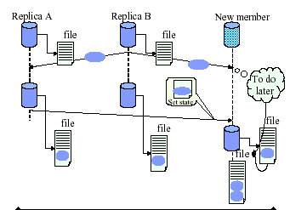

Above Figure shows one scenario, where the replica sending the state receives and processes the new message before sending the state. If the new member receives first the append message, it saves it for processing after receiving the full state. Then, it adds the new chunk, terminating in an inconsistent state.

However, the append message needs to be saved, as shown in figure below.

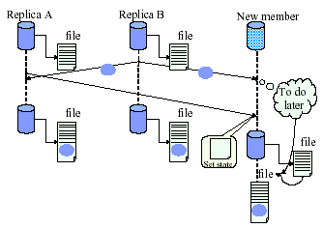

In this figure, the state is sent before processing the append message, and therefore the joining member must have saved the message to get a final consistent state.

FTDA allows a special behavior mode, which roughly means excluding the involved members during a transfer, which then must process any delayed message before re-joining the group. To use this feature, messages must be defined as

DomainMessages, defined in IDL CORBA as:
valuetype DomainMessage : Message {
public boolean unqueuedOnST;
public boolean untransactionable;
. . .
};

The first field indicates when a message is received even during a state transfer, and it is false by default. The second field is explained in the next section. The support of state transfers in several steps is useful for big components, but its advantage is in its optimization possibilities. A container is blocked while it is transferring its state; if it can transfer it in several steps, it is blocked more times but for less time, giving probably a faster answer to its user when the state is big. The state transfer becomes more complex, and the container must deal with messages received during the state transfer, probably modifying its state, but this is completely hidden to the final application.

FTDA extends the flexibility on state transfers by allowing the applications to choose the members that make the transfers. An application requiring fast answer times could allocate a replica to do this task exclusively; none of the other replicas servicing client requests would be blocked because of state transfers.

Transactions

In our model, a transaction is the mechanism used to avoid inconsistencies across multiple replicated components when a running process or its host falls down. Although transactions can be based on undoable components, allowing at the same time the possibility to abort transactions, this design would transfer to those components most of the transaction support. This would translate into a more difficult implementation of those components but also into a more difficult and less transparent use.

The implementation used in FTDA, based on delaying group communications during the transfer, implies two problems related to the virtual synchrony model. First, not every member in the group observes the same messages in the same order. Second, the group could install a new view during a transaction, and because it is not possible to cancel the transaction, not every member in the group would observe the same messages between two consecutive views. Therefore, the use of transactions under this second design violates the virtual synchronous model. However, as their use depends on the application, this can choose whether that violation is permissible.

The approach is then to avoid the possibility of such concurrent updates by using monitors. Therefore, transactions are built in FTDA around distributed monitors, protecting the components inside the transaction against other external parallel updates, at least if the other updates are also carried out properly by first locking the same monitor. Two transactions can be done in parallel using different monitors, as far as the component updates to be carried out, they can be performed concurrently. If a component can be queried without first acquiring a lock, it means that the message associated to that query can be processed without affecting other component messages.

The second problem is that not every replica observes the same messages between two different views. This means, as happened with the state transfer support, that applications relying strictly on the virtual synchronous model will not behave properly using transactions. In the case of an application based on the certainty that fallen down replicas have been able to process every message up to a specific view, the security that the living replicas have no inconsistencies is not sufficient to maintain the application requirements.

Therefore, our proposal for transactions and their implementation in FTDA completely depends on the quality of the code being using. If a replica updates its components or group of components guarded by a monitor or a transaction, the violations on the virtual synchronous model are not translated into inconsistencies on their states.

Transactions and monitors

The interface on domains to support transactions is very simple, based on the definitions of monitors, that in JavaRMI, without the specification of exceptions, is:

public interface Monitor extends Remote{
public void lock() throws …;
public void unlock() throws …;
};
public interface TransactionsHandler extends Remote {
public void startTransaction(Monitor monitor) throws…;
public void endTransaction() throws …;
};

The possibility to nest transactions is essential to keep the components abstraction. Otherwise, if a component uses a transaction internally, this component could not be used by others under another transaction, making the use of transactions inside components potentially impossible.

To start a transaction requires first locking a monitor, but if communications are not sent to the group, that lock would be totally useless, as other members would not be aware of it and could therefore lock the same monitor themselves, probably resulting in replica inconsistencies. For this reason, not every group communication is blocked during a transaction. As seen in the previous section, messages in FTDA can include a flag that defines them as not being blocked on transactions.

Messages queued under a nested transaction are not sent to the group until the outer transaction is finished. Otherwise, another replica could start a transaction over a component that does not reflect its latest state. The same applies to the unlocking of a monitor: while locking a monitor is translated into a non-blocked message to the group, unlocking a monitor produces a message that is queued together with the other messages in the transaction.

State transfer for active replicas in CORBA

Project addresses the open issue of state transfer in groups of active replicas under an application-controlled consistency style, which must be flexible to cope with different application requirements, such as transfer of large states, non-blocking during state transfer, and coordinator election.

Introduction

The Object Management Group (OMG) has just approved the standard for Fault Tolerant CORBA [OMG99]. This deals with replication of objects (instead of servers) in a CORBA environment. The standard tries to support a wide range of requirements, such as passive and active replication modes, control of the creation and the consistency of the replicas by the application or the fault tolerance infrastructure, automatic or application-driven checkpointing, logging and recovery from faults, while keeping minimum impact in the ORB.

The state transfer in groups of active replicas under an application-controlled consistency style, which must be flexible to cope with different application requirements, such as transfer of state in one step or in several (for large states), blocking or non-blocking of server object groups during state transfer, and election of coordinator for the state transfer.

Fault Tolerant CORBA

The key component of the Fault Tolerant CORBA architecture for management of the object group is the ReplicationManager, which should be also replicated to be fault tolerant. The ReplicationManager interface inherits three interfaces: PropertyManager, GenericFactory,
and ObjectGroupManager.

The PropertyManager interface allows the user to define fault tolerance properties of object groups, that basically determine the responsibilities of the infrastructure. The most relevant properties are ReplicationStyle, MembershipStyle, and ConsistencyStyle.

The ReplicationStyle sets how the state is maintained on the replicas; it can be stateless, cold passive, warm passive, active.
Passive replications are based on one single member, the primary member,processing every method invocation to the group, which contains as well backup members. In the case of warm replication, backup members are updated periodically with the state of the primary replica; in the case of cold replication, this update is only done when needed for recovery.

Under active replication, every replica processes each method invocation, and duplicated requests or replies are suppressed.

The MembershipStyle determines whether group membership is under the responsibility of the application (application-controlled) or the infrastructure (infrastructure-controlled). In the latter case, the ReplicationManager invokes the required factories to create the members needed to satisfy the group properties, like the initial or the minimum number of replicas. In the first case, the ReplicationManager provides the operations to do manually the insertion and extraction of members in groups, to define the primary member and the locations of each group member.

The ConsistencyStyle can also be application-controlled or infrastructure-controlled. When controlled by the application, this must maintain its own consistency at each moment: after each group invocation or when a new replica is added, which must therefore receive the appropriate group’s state. Alternatively, when controlled by the Fault Tolerance infrastructure, the application group objects must just implement a basic interface, Checkpointable, which provides simple setState and getState methods.

interface Checkpointable {
State get_state ();
void set_state (in State s);
};
interface Updateable : Checkpointable {
State get_update ();
void set_update (in State s);
};

Optionally, objects can implement a specialized interface, Updateable, which also defines the operations get_update, set_update, to store and retrieve the state incrementally. The infrastructure keeps the checkpointing, logging, activation and recovery mechanisms required to maintain a strong consistency and to install the group’s state on any new replica. This consistency means, under the passive replication, that after a state transfer to a backup member, this is consistent with the primary member (or the previous primary member, if cold replication).

Under active replication, the strong consistency requires that after each method invocation, every replica has the same state. If the replication is not stateless, the behaviour of each member must be deterministic and each member must start in the same state. This specification means that when the Fault Tolerance infrastructure must keep strong consistency, replicas are periodically requested for their state. The infrastructure stores the messages processed by every replica and requests the state to the replicas according to the CheckpointInterval property (defined in units of 100 nanoseconds).

When a new replica is included in the group, the state can be built from the last stored state and the log of messages that have been processed after the state was retrieved. Each replica must store periodically checkpoints of its state, and keep a trace of the messages processed from the last checkpoint. If a replica becomes active, it can build its state from those checkpoints. JavaGroups does not invoke automatically the transfer; this is an operation to be called by the interested member, who can request the state from every group member or just from one, generally the oldest one. The member sending its state must first make a copy of its state, and while this copy is performed, the member is blocked. When the state is requested, the member just sends this temporary copy. It is a transfer in one step, and requires total ordering on the messages; the interface is slightly more complex, to do the state copy: SaveState, GetState, SetState.

This paper specifies a state transfer interface for those active CORBA groups under an application-controlled ConsistencyStyle. This interface must allow flexible transfers to be adapted to any generic group. The following section includes the requirements for the state transfer, with the adaptations needed to the fault tolerance IDL specification, and the section after shows several use cases for a better understanding of this proposal.

State transfer requirements

On an active group, two cases require a state transfer. First, when one or more members join the group and need to receive the state from the old members. Second, when the group has been partitioned due to network problems, with the subgroups progressing independently, and the group is re-merged, making a state transfer necessary between the subgroups. This second possibility is not afforded in the project for two reasons: its complexity and the extra requirements needed to keep the consistency (Fault Tolerance CORBA specification does not address object group partitioning either).

Although every member in the group has at any moment a specific state, only those members sharing a common, initialised state will be considered as state members. Those members whose state is not coherent with this global state are considered as stateless members.

The simplest state transfer from an active group to one or more joining members consists of the state being sent in one multicast message from one state member. The joining members receive it and the other active members see the message as the trigger to consider that the transfer has finished. The selection of the member that sends the state can be based on the properties of the view synchrony model as every group member receives the same ordered list of members, called a view. According to this, one possibility is to select the state member with the lowest range in the view. This member is the coordinator of the state transfer.Several circumstances can make this scenario more complex. If the state to transfer is large enough, it should be sent in more than one message, in order to avoid blocking the coordinator while it builds the message with the state (as no updates can be performed on that member in the meantime). The possibility to send the state in several steps implies as well that a transfer can be cancelled due to a failure of the coordinator; in this case, a transfer synchronization is required. The interface should anyway stay simple if the transfer is done in one step.
Other point that can affect the performance of the group is the election of the transfer coordinator. An application can select one member to do every transfer. This member will normally perform worse that the other members, but frees them of doing this task. At the other extreme, a different member can be selected each time a transfer is required, to achieve load balance.

Additionally, because a member can be selected to do several transfers, these transfers can be done concurrently or sequentially. Finally, group blocking must be taken into account while the transfer is performed (i.e., the group does not accept method invocations while the state transfer is performed). If the coordinator can update its state during the state transfer, a re-synchronization will be needed. A simple way to avoid this additional complexity is blocking the group during the transfers, but the performance can degrade dramatically if state transfers are required very often.

Transfer synchronization

The basic functionality to keep consistency of state is covered by the existing Checkpointable interface, enough to get and set the state. However, if the state is transferred in several chunks, some synchronization is needed between the stateless member and the coordinator to identify the chunk being transferred; this synchronization is also needed to restart a previously cancelled transfer. Although the state chunks can include the required synchronization, to define a separate object for that purpose allows for a better and clearer design. This object is called phase coordination, and it is defined by the application; from the transfer system’s point of view, this phase must just flag when the transfer has finished. An example of a phase object is one containing the number of chunks to transfer and the next chunk to be transferred, flagging the end of the state transfer when both numbers are equal.

abstract valuetype PhaseCoordination
{
boolean isTransferFinished ();
};

The definition of this object makes use of the Objects by Value functionality. If an interface would be used, the checking of the end of the transfer would need a remote call. If a structure were used, there would be no possibility to extend the type to include the specific application behaviour, as IDL structures do not allow inheritance.

When a state member is called to obtain its state, it must return the PhaseCoordination associated to that state, which is transferred to the joining member. As state transfers are now done in several steps, if the state member fails, a new transfer should be started from the beginning. In order to allow the continuation of a cancelled transfer, two new methods are added. sync_transfer is called on the stateless member to specify the next PhaseCoordination expected; this phase is passed to the coordinator as a parameter to a method start_transfer These methods are specified in the interface StateHandler, which has no connection with the Checkpointable interface. To specify when a group is using the basic functionality or the extended one proposed here, we define a group property UseBasicStateTransfer:

typedef boolean UseBasicStateTransfer;
interface StateHandler {
void start_transfer (in Location joining_member,
inout PhaseCoordination phase);
void sync_transfer (in Location coordinator,
inout PhaseCoordination phase);
State get_state (inout PhaseCoordination phase);
void set_state (in State s,
in PhaseCoordination phase);
};

- start_transfer: call to the state member when a transfer is going to start, to allow any preprocessing that the application may need to perform, and to synchronize the transfer with the joining member. It returns a phase which will be used in the next call to get_state.
- sync_transfer: call to the stateless member when a transfer is going to start. If there was already a transfer and the previous coordinator failed, this method is called with the last received phase (a nil reference if it is the first transfer), and must return the next expected phase.
- get_state: the state will be requested while the phase returned does not flag the end of the transfer.
- set_state: called on the stateless member.

The previous interface is only valid when the transfer includes one coordinator and only one new member receiving the state. The reason is that the probability of having several members joining the group at the same time, and therefore targeting the same transfer, are usually very low. The coordinator could still be programmed to do several unrelated transfers at same time,but the performance increase obtained could not be appreciable, as the application must support several threads getting the state at the same time, and solve the potential synchronization problems.

Coordinator election

There are different strategies to select the state member that will be responsible for controlling a state transfer:

Our proposal introduces a new concept: properties associated to each member. If the application is going to choose the coordinator, it is presented with a list of the state members, along with their associated properties. If the election is automatic, each member can have a weight associated, and that weight is used by the infrastructure to choose the coordinator. This weight behaves as a predefined property with name FT::COORDINATOR_WEIGHT. When the coordinator is chosen by the application, its object members must implement the interface CoordinatorElector, which defines one method called get_coordinator: the locations of the state members are presented, and one location must be returned deterministically.

interface CoordinatorElector
{
Location get_coordinator (in Locations locations);
};

Member properties

The state of a group can be seen as the state of one member that is the only member in the group. However, properties are associated to each specific member, and should have no visibility outside the group. In other words, properties are not part of that state and no output from the group should be affected by those properties. Only group domain operations should be affected, like the choice of the member that must perform some specific task. Examples of such properties are the location of each member, or their weight or responsibility to perform specific tasks.

Other difference between the global state and the member properties is the required transfer. When a member joins a group, this group must transfer its state. However, the properties must be transmitted in both ways: a new member is considered to have properties but not an initial state.

The PropertyManager interface provides methods to set properties statically as defaults for any group created by that manager, or dynamically for a specific group.

typedef CosNaming::Name Name;
typedef any Value;
struct Property
{
Name nam;
Value val;
};
typedef sequence <Property> Properties;

We define two additional properties, for the use of member properties and the coordinator

election: UseMemberProperties, CoordinatorElectionStyle.
typedef boolean UseMemberProperties;
typedef long CoordinatorElectionStyleValue;
const CoordinatorElectionStyleValue
COORD_ELECTION_INF_CTRL = 0;
const CoordinatorElectionStyleValue
COORD_ELECTION_APP_CTRL = 1;

The PropertyManager interface granularity allows the specification of properties for groups, not for the members themselves. However, it is possible and effective to specify a new predefined property that associates for each location a set of properties. If the group uses an infrastructure-controlled membership, the properties will be transferred to the factories creating the individual group members; otherwise, the application itself must specify the properties when the objects are created.

The PropertyManager interface includes a method to modify dynamically the properties of a group, PropertyManager can be used to specify the initial properties of the group members, and the factories (interface GenericFactory) receive the properties of a member when this is created.

interface GenericFactory
{
Object create_object (in TypeId type_id,
in Criteria the_criteria,
out FactoryCreationId id);
void delete_object (in FactoryCreationId id);
};

In our proposal, these properties are included in the Criteria parameter in an entry named FT::FT_MEMBER_PROPERTIES: a member only receives its own properties, the other's are received during the state transfer. Properties are received and can be dynamically changed through the interface PropertyHandler, to be implemented by the object members.

interface PropertyHandler
{
Properties get_properties (in Location location);
void set_properties (in Location location ,
in Properties properties);
};

To change the properties, a member must invoke set_properties on the object group reference, specifying its own location and its new properties.

Group composition

As stated in the fault tolerance specification, the active replication requires the use of a multicast group communication system providing reliable totally-ordered message delivery and group membership services in a model of virtual synchrony. Under this model, group members usually receive events related to the group membership, like the view of the group, with the ordered list of members. This list can be obtained under the current specification with the method locations_of_members in the ObjectGroupManager interface. Nevertheless, a member cannot be considered as belonging to a group until it has received the state. During the state transfer, it is needed to block any action on the coordinator and joining members, as these actions could modify the transferring state, and both members would likely finish in inconsistent states. When the transfer finishes, the blocked messages can be unqueued and processed. Only the coordinator and the joining member are blocked; they can be seen as slower members, not performing any action until the state is transferred. To be able to know at each moment the real composition of the group, that is, the list of state members, we include an additional method in the StateHandler interface:

typedef sequence<StateHandler> StateView;
interface StateHandler {
...
void state_view (in StateView s);
};

StateHandler interface

- The application creates a new member in a group with the property UseBasicStateTransfer set to false. An existing state member is chosen as coordinator.
- The method sync_transfer is invoked on the interface StateHandler implemented by the joining member. A nil reference is passed as parameter, besides the location of the coordinator.
- The coordinator’s method start_transfer is called with the location of the joining member and the phase returned after the call to sync_transfer. The coordinator must return a phase object.
- This phase object is passed back to the coordinator on the next call, to the method get_state. It must supply the first chunk and a phase object that will be transferred to the joining member through the method set_state.
- While the phase returned by the coordinator does not flag the end of the transfer, the previous step is repeated.
- If any of the members involved in the transfer fails, the other member learns about it through the FaultNotifier. If the coordinator is the member failing, a transfer is restarted by choosing a new coordinator. The method sync_transfer is invoked again on the joining member, but this time it receives the last PhaseCoordination object received, instead of a nil reference. It can then choose whether the whole state must be transferred again, or just continue the interrupted transfer, by modifying that object.
- When the transfer finishes, every member in the group receives a new state view with a call to the method state_view.

Coordinator selected by the application

- A member is added to a group that has defined the property coordinatorElection-StyleValue as COORD_ELECTION_APP_CTRL.
- If the fault tolerance service uses pull transfer, the method get_coordinator is invoked on the joining member. Under push transfer, the method is invoked on every state member. In both cases, the member must choose the coordinator between one of the members passed to the method as parameter.

Coordinator selected by the infrastructure

- A member is added to a group that has defined the property CoordinatorElection-StyleValue as COORD_ELECTION_INF_CTRL.
- If the group does not use member properties, any state member can be chosen as coordinator.
- If the group is using member properties, state members are accessed to obtain the properties of the current members (method get_properties under the PropertyHandler interface).If property FT::COORDINATOR_WEIGHT is defined, the infrastructure selects as coordinator the member with lower relation scheduled_transfers / weight. If the property is not defined, any state member can be chosen as coordinator.

Use of properties under an infrastructure-controlled membership style

- The application invokes the create_object method of the GenericFactory implemented by the ReplicationManager, supplying the type_id and properties through the Criteria parameter.
- The ReplicationManager obtains the fault tolerance properties for the object group from the PropertyManager of the type_id specified. These properties can be overridden by others specified in the Criteria parameter under the entry called FT::FT_PROPERTIES.
- The ReplicationManager decides the locations at which to create the members of the object group.
- For each location, if the group properties define UseMemberProperties as true, an entry called FT::FT_MEMBER_PROPERTIES is searched, and inside this entry, the properties for the specific location are obtained.
- The member properties, when defined, are passed to the object being created with the create_object method of the appropriated factory, under the Criteria parameter.
- Once the object is created, it receives the properties of the other group members through successive calls to the method set_properties on the PropertyHandler interface, once for each existing state member.

Use of properties under an application-controlled membership style

- Members created directly by the application using the local factory, receive their properties through an entry called FT::FT_MEMBER_PROPERTIES in the Criteria parameter.
- Members created by the create_member method in the ObjectGroupManager interface implemented by the ReplicationManager receive their properties in the same way, as that method defines as well a Criteria parameter (the local factory is called indirectly).
- Once the object is created, it receives the properties of the other group members through successive calls to the method set_properties on the PropertyHandler interface, once for each existing state member.

This state transfer introduces a flexible state transfer scheme complementing the basic one defined in the current fault tolerance CORBA specification. The domain of this proposal is composed by the active groups using an application-controlled consistency style, where the logging and recovery mechanisms defined in the specification are not suitable enough. The basic idea supporting the scheme flexibility is the splitting of the state to be transferred in several chunks. The application can also decide how to handle interrupted transfers, or which state member is more appropriate to coordinate a specific state transfer. It is also possible to define member properties, as a feature separated from the concept of group's state. These features are specified with a high adaptation to the fault tolerance specification, and there is no need for additional changes to the CORBA specification. Most of these features are configurable through the use of object group properties, and only three new interfaces are defined: StateHandler, to handle state transfers, PropertyHandler, to allow the dynamic change of properties, and CoordinatorElector, to allow the selection of transfer coordinators by the application.
Example Application

Scripts & Batch Files Description
The directories scripts and scripts.win contain scripts for use under Linux (sh) and Windows, respectively. To use them, it is needed first to edit the file FTDAVars (or Vars.bat) with the right values for: FTDAHOME: where FTDA is located
All the examples are available for RMI and CORBA. Before running any of the scripts, it is needed to specify the environment to use, using any of the following scripts:
- useCORBA: sets the environment to use the CORBA version, using the JDK's orb
- useRMI: sets the environment to use the RMI version
This scripts will check if the libraries are present, and define some environment variables needed by the exmaple's scripts to execute the supplied examples.
Once that the environment is set, just run the specific script, supplying any desired arguments. Most of the examples supports the argument '-help' to list the accepted arguments.

Random Counter
It is a simple GMS program, does not make use of the Domains facilities. It requires the GMNS server to be present.
This is the best example to understand GMS. It has RMI and CORBA versions, but with separated code and with no GUI.
The servers must generate unique random numbers and, of course, two different servers must still service different numbers. The example gives numbers from 0 to 4; only after giving all the numbers, it can generate again the same numbers. Because it just shows the GMS functionality, it does not include any state transfer. For this reason, all the servers should be started at same time.
The script used to start the example is exRandomCounter. It admits two options (in addition '-help'), and it must be always specified the name of the group (in the GMNS server); the two options are:
- -config=configuration file : specifies a different configuration file.
- -server : if specified, it is started as server, otherwise is a client.
For example, to start two servers on two different terminals, belonging to a group called 'example', the input under Linux can be:

/local/FTDA/scripts> exRandomCounter.sh -server example
The output for a client will be:
$ exRandomCounter.sh example
Requesting unique number...
Number served: 3
One of the servers will produce an output like:
Sets use up to 5 numbers
Server in group, starting serving requests
Received request to generate number
Number generated: 3
And the other server that has received the request:
Sets use up to 5 numbers
Server in group, starting serving requests
Sending request to generate number...
Received request to generate number
Number generated: 3
The number generated on this request is: 3

Chat
It is as well a simple GMS program, does not make use of the Domains facilities. It features a Chat program: every client can write messages, that are seen but every other client in the same order.
It requires a GMNS server to be present, where it creates a group called 'ChatMember group'. Any other CORBA client will start automatically 'speaking' with the already existing clients. There is no state transfer support, that is, the new clients do not see the old messages.
The script, exChat, does not accept arguments. The GUI looks like:
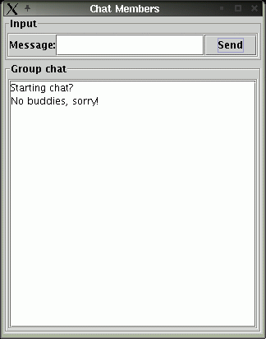

Performance GMS
It is written to check the performance of GMS: number of messages that can send or receive on the group. It requires the presence of the GMNS, where it creates a group called 'performanceGMS'.
The script, exPerfomanceGMS requires two parameters: the name to be used on the GMNS server, and the resting period: time to elapse before sending the next message. For example:
/local/FTDA/scripts> exPerformanceGMS.sh name 10
The output shown is something like:
Member accepted in group
received (2500) sent (2502) msg/second: 0 total: 0
received (5000) sent (5000) msg/second: 99 total: 97
received (7500) sent (7501) msg/second: 99 total: 97
received (10000) sent (10000) msg/second: 99 total: 98
received (12500) sent (12504) msg/second: 99 total: 98
Exact numbers depend on the number of servers in the group, on the middleware (RMI or CORBA)

Concurrency
This is an application showing some of the features of Domains, those related to the concurrency mechanisms.It creates members sharing three replicated monitors, which can be locked or used to start transactions. It is also possible to create dynamically new monitors. The only other interaction between members is the sending of messages (queued during transactions).
When started with the argument '-help', it shows the accepted arguments:
arguments: [options...]
Options:
config=configuration file
--> FTDA properties file
group=group name
--> group name if a GMNS service is running
name=name
--> Identifies this monitor (logging & GMNS)
connect=group member reference file
--> file with the reference of a group member to join
reffile=reference file
--> file to include the reference of this server
help
--> shows this brief help
If 'group' is used, the groups are created through the GMNS. Nevertheless, it can dump the server references to a file, using the 'reffile' argument; in this case, other member can join this one specifying this file with the argument 'connect'
It is possible to associate a name to the member's instance, which is shown in the GMNS GUI's interface, if used, and to name the logging file, in case that logging is used.When the script, exConcurrency, is started, it shows first the allowed instructions:
Member accepted; id=177513472
State obtained, monitor's functionality becomes available
----------------------- HELP --------------------------------
~~~~~~ (Lx): lock monitor --------- (Ux): unlock monitor
~~~~~~ (Sx): start Transaction ---- (E): end Transaction
~~~~~~ (C): create monitor -------- (Rx): remove monitor
~~~~~~ (?): shows this help -------- (Q): quit
The initial monitors are x=1,2,3
-------------------------------------------------------------

>_

For example:
- L1: locks the first monitor, if it is available (or locked by this member).
- U3: unlocks the third monitor, it does nothing if this member does not own it.
- C: creates a new monitor. It identity is given by FTDA.
- R65536: destroys the monitor with identity 65536. Only dynamic monitors can be destroyed.
- S1: starts a transaction, locking the given monitor. Any message sent from this moment to the group is queued until the transaction ends. But the member in the transaction receives the messages.
- Any other input is just understood as a message that is sent to the group.

Domains Test
When started with the argument '-help', it shows the accepted arguments:
arguments: [options...] [properties]
Options:
config=configuration file
--> FTDA properties file
group=group name
--> GMNS name
connect=group member reference file
--> file with the reference of a group member to join
reffile=reference file
--> file to include the reference of this server
subgroupsNoST= subgroup1-subgroup2...
--> initial subgroups without ST to create
subgroupsChP= subgroup1-subgroup2...
--> initial subgroups Checkpointable to create
subgroupsEChP= subgroup1-subgroup2...
--> initial subgroups ExtendedCheckpointable to create
subgroupsBSH= subgroup1-subgroup2...
--> initial subgroups BasicStateHandler to create
subgroupsSH= subgroup1-subgroup2...
--> initial subgroups StateHandler to create
mode= ME(members excluded)
/NME(new members excluded)
/NMB(new members belong)
coordinator= inf(infrastrure controlled)
/weight(selected on weights)
/user(selected by the user)
dynamic
--> enables dynamic subgroups
join
--> joins/creates inmediately the group
automatic
--> starts on automatic mode
delay= time in milliseconds
--> sets a delay to automatic mode
events
--> shows the events window
properties
--> enables the properties
help
--> shows this brief help

Properties: defined as -Dkey=value. name & weight have special meaning.
If 'group' is used, the groups are created through the GMNS. Nevertheless, it can dump the server references to a file, using the 'reffile' argument; in this case, other member can join this one specifying this file with the argument 'connect'
Other arguments are deeply associated with the methodology supported by Domains. These arguments are 'properties', which enable the application to use properties, 'dynamic', which enable the application to create dynamically replicated components, 'coordinator', explained later, and 'mode', which defines the behaviour of the components during the state transfer when there are view changes..

This example is based on a specific component, which just holds a list of colours. The user can, at any moment, add a new colour (randomly selected) or remove the last one. The program allows to create any number of components, or statically (before joining the group) or dynamically (once the group has been joined). The last case is only supported is explicitely specified.
The focus of this test is on the state transfer capabilities of FTDA. Domains specified five types of transfer: no transfer, checkpointable, extended checkpointable, basic state handler and state handler.
For this reason, even when there is only one type of component, there are five different implementations, one for each kind of state transfer.
These components can be created statically on the command line using the arguments '-subgroupsNoST', 'subgroupsChP', 'subgroupsEChP', 'subgroupsBSH' and 'subgroupsSH'. For example, using:
/local/FTDA/scripts> exDomainsTest.sh -subgroupsBSH=1 -subgroupsChP=2
two components are created, one with transfer 'basic state handler', and other as 'checkpointable'

The GUI of the application shows the following appearance:

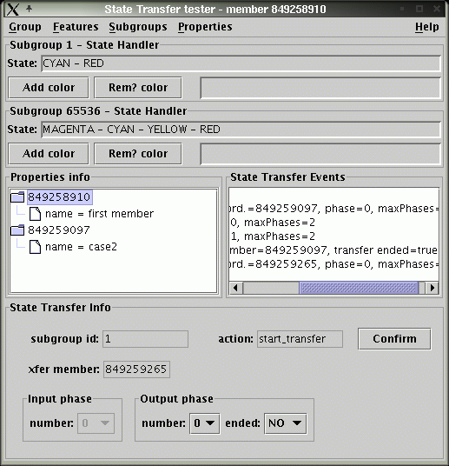
This image shows two components (called subgroups),
one static (identity 1), and with dynamic (identity is 65536); both belong to the more complex type of state transfer. Below the subgroups panel, there is a panel showing the properties, including those of the two current members, and another panel showing the state transfer events.

The application can run on automatic and manual modes. On manual mode, the window shows at the bottom the state transfer panel, like it is shown on the figure. In this case, the user must answer to all the events received during the state transfer. Note, in this case, that a too slow user input can make the member be excluded from the group.
The automatic mode is entered using the argument '--automatic'; in this case, it is possible as well to introduce a delay on the answers given for each state transfer event, using the argument '-delay'.
For each new member joined to the group, other member is selected as coordinator to perform the state transfer. The election of this coordinator can be modified using the argument '-coordinator', which accepts three values: 'inf', where internal logic in FTDA is applied, '-user', where every time the user is asked to select a valid coordinator, and '-weight', where load balancing is applied based on the weights given to each member. It is possible to give a specific weight to a member by using the propertie 'weight'. Properties are specified with the argument '-D'. For example:
/local/FTDA/scripts> exDomainsTest.sh -Dweight=4 -Dname=server_ONE
This example assigns a weight of '4' and the name 'server_ONE'.
When the member is created, it does not join the group unless the argument '-join' is used. The user can then modify the member using the GUI, and join later the group explicitely.
Note that when a member joins a group, it must define the same properties that the other members in the group. For example, falling to define the same set of static subgroups gets to the exclusion of the member as soon as it joins the group.

Tester GMNS
This last example is used to check the correctness of GMNS. It requests continuosly from one GMNS server the inclusion of members in one of several predefined groups. This members are terminated randomly, and the GMNS must detect it and remove them from its register, updating the GUI.
The test is completed by having several GMNS servers; several clients (testerGMNS) can then be executed against the different servers, to stress the correcteness of the system.
The script, exDomainsTest, accepts one argument, '-config', to be able to specify different configuration files and, therefore, different GMNS servers.

All The Scripts

FTDAVars | This script must not be manually executed. It must be edited to define some variables related to your specific configuration, specifying where is FTDA installed
_launcher | Internal script, used to launch most of the other scripts.
Configuration | Scripts that set the environment to use an specific configuration  They are executed directly in Windows, and with source in Linux.
useCORBA | Sets the environment to use CORBA, with the ORB bundled with the JDK (only in 1.4).
useRMI | Sets the environment to use RMI.  The optimized version of FTDA, without assertions or tracing, is selected.
gmns | Starts the GMNS server.
FTDAConf | Shows graphically the FTDA's configuration.
Examples | Scripts associated to the examples.
exChat | Starts the Chat example.
exConcurrency | Starts the example Concurrency.
exDomainsTest | Starts the example Domains Test.
exPerfomanceGMS | Starts the example Performance GMS.
exRandomCounter | Starts the example Random Counter.
exTesterGMNS | Starts the example Tester GMNS.

Configuration

GMNS Usage
GMNS, specifies the functionality to create or extend subgroups.It includes two parts:
- A utility where the client must supply the reference of other group member to join its group.
- Directory service. With the directory service, clients just specify the name of a group, and the server takes care of finding other member to perform the join.
To use the utility, it is not needed to execute the GMNS server: the scripts gmns.sh or gmns.bat are used to start the directory server.
The directory server is a replicated application: it should be running on every host where a group is to be existing, although this is not required. As a matter of fact, it is enough to run the directory server on one host, but should this host fall down, no members would be able to join or create new groups!!!
To execute the GMNS server on several hosts, it is important to specify right Configuration values; the important values, (all the GMNS configuration values are explained below) are those that specify the references to other GMNSs.
Each GMNS must publish itself; it can use a URL, or a TCP/IP port. In the first case, it must supply a valid file on the configuration value GMNS.referenceFile. In the second case, the port to be used (is always published on the host where it is executed), must be specified on the configuration value GMNS.referencePort.

For example, a GMNS running on the host 201.23.23.1 which wants to be accessed on the port 12500, should specify GMNS.referencePort=12500
Other GMNS's configuration file must now be able to give the localization of the previous GMNS. To do it, it must first specify, using the configuration value GMNS.hosts, the number of available GMNS servers. For each of these GMNSs, it must be specified, or their TCP/IP socket, or their URL. Following the same example, it could give the values shown below:
GMNS.hosts=1
GMNS.hostSocket.1=201.23.23.1:12500
If a server is reachable via a URL, instead of using GMNS.hostSocket.xxx, the configuration property is GMNS.hostURL.xxx.
Configuration values
FTDA is configured on a single properties file, which contains values for all the subsystems. The table of properties, together with the default values, is explained below.
FTDA tries by default to open a file called FTDA.properties, which can be located in any of the following places:
- Current directory: directory where the program using FTDA is started.
- User's home directory.
- Java's home directory.
If no configuration file is found, FTDA will use default values.

Nevertheless, any application can force FTDA to use a different file. For example, most of the examples (and GMNS itself) support this configuration file through an argument on the command line, usually called conf or config, that must be used like:
gmns.sh -conf=/local/specificGMNSconf.FTDA

Value | Meaning | Default value
GMS.channelLivenes | Period, in milliseconds, after which a channel is considered faulty. | 10000
GMS.maxProcessMessageDelay | Timeout, in milliseconds, for an application to process a message. Otherwise, the application is considered slow and excluded from the group | 5000
GMS.tokenStoppedPeriod | Period, in milliseconds, that a group member holds the token when there are no group communications. | 50
GMS.tokenLostTimeout | Timeout, in milliseconds, to receive a token; if not received in this time, it is considered lost, and the member will start the recovery protocol. | 6000
GMNS.referenceFile | The file to store the reference for the current GMNS instance.  Only this ot the referencePort are needed.  If the referenceFile is present, the referencePort is not used. If both are unspecified, the default port is used | N/A
GMNS.referencePort | The port to export the reference for the current GMNS instance. | 1212
GMNS.backupFile | The file to store the backup information for the current GMNS instance | GMNS.backup
GMNS.backupPeriod | Periodic time (in milleseconds) to store the GMNS information on the backup file. | 300
GMNS.checkPeriod | Period (in milleconds) to check the members registered in the GMNS  server. | 10
GMNS.hosts | Number of other GMNS hosts, whose reference must be then specified using their TCP/IP addresses or URL files. | 0
GMNS.hostURL. | Each host must specify its URL or TCP/IP. | N/A
GMNS.hostSocket. | Each host must specify its URL or TCP/IP. If there is just other GMNS host published on the host 192.23.34.1 and port 15450, it would be needed to specify (with GMNS.hosts=1):  GMNS.hostSocket.1=192.23.34.1:15450 | N/A
GMNS.collisionTimeout | Defines the period (in milliseconds) to wait when 2 GMNS starting at the same time, discover themselves mutually. In this case, one must wait this period while the another one completes its initialitation. | 2500

Showing the configuration (GUI)
FTDA is distributed with a GUI to show the configuration values, although is not possible to edit them with this program. The class to be invoked is FTDA.util.FTDAConf, which admits as argument the file to show; if no arguments are specified, it shows the FTDA properties file found (by default, the file called FTDA.properties in the current directory, or in the user's home directory or in Java's home directory), or, if not found, just the default values.
There is as well a script that can be invoked :
Linux: FTDAConf.sh [file]
Windows:FTDAConf [file]
The GUI has an appearance like:

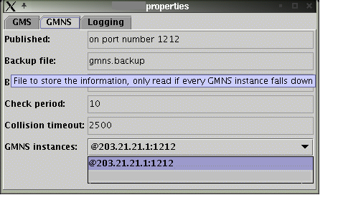

Screen Shots

Group Messaging

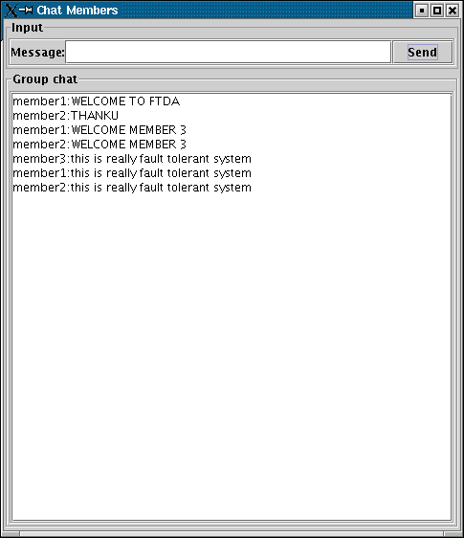

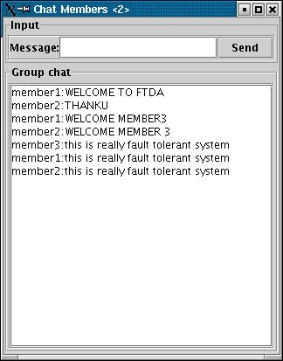

GMNS

Property’s Display

GMS

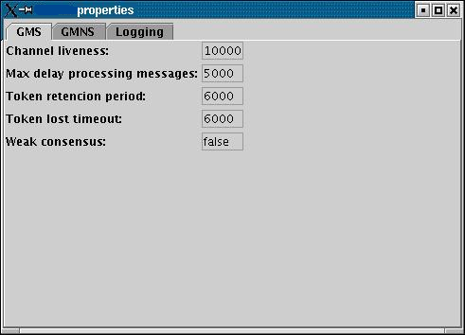

GMNS

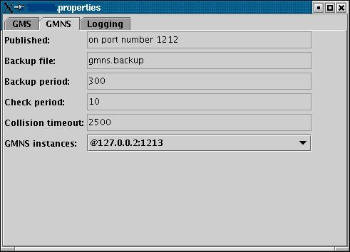

Concurrency Test

Client 1

0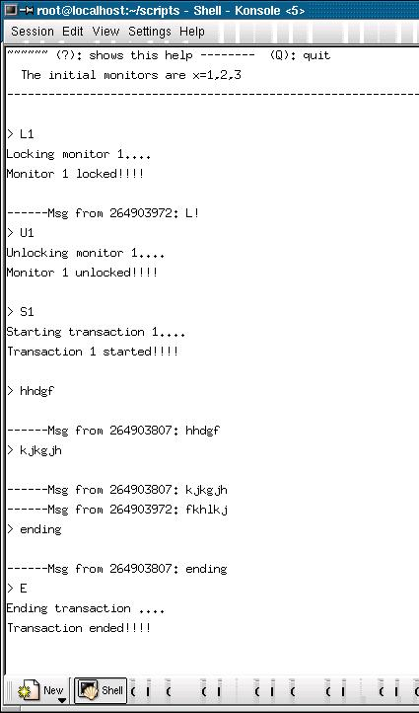

Client 2

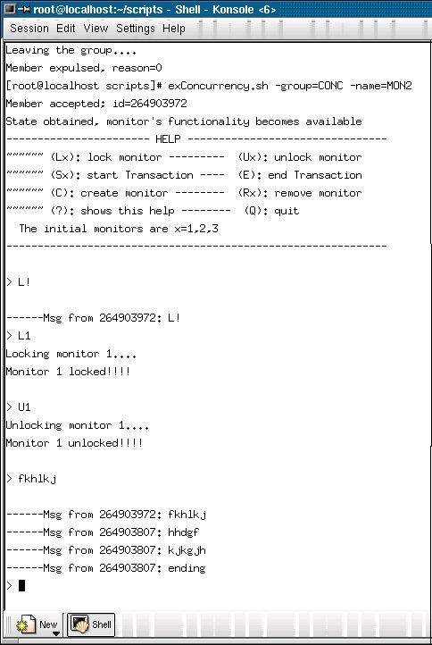

RandomCounter
The output for a client will be:
$ exRandomCounter.sh example
Requesting unique number...
Number served: 3
One of the servers will produce an output like:
Sets use up to 5 numbers
Server in group, starting serving requests
Received request to generate number
Number generated: 3
And the other server that has received the request:
Sets use up to 5 numbers
Server in group, starting serving requests
Sending request to generate number...
Received request to generate number
Number generated: 3
The number generated on this request is: 3

Testing

Unit Testing

Unit testing focuses on the smallest unit of software design. Using the component level design description as a guide ,important control path are tested to uncover errors within the boundary of the module.

Unit testing is White Box oriented,& the step can be conducted in parallel for multiple components.

In unit testing each module is tested in the environment of project work & effect of other modules is observed in that module,

We have tested our all the modules as a stand alone unit. To understand the fault tolerance we worked on 5-6 computer connected via a LAN and tried all possible cases.

To understand the architecture we developed some applications and then examined the system.

Integration Testing

And all the modules are tested separately & then I performed integration testing to observe the efficiency & working of all the module as a one unit.

When we tested our project following errors are found

- It was hard to install the package and set CLASSPATH separately so we converted whole binary distribution in tar file and created scripts (Unix / Linux) and batch files (windows) to set environmental variable.
- Network configuration (hardware) must be error free. Otherwise FTDA wont perform accurately

Conclusion

The goal of our project was to create a Fault-Tolerant application using the concept of Active Replication. With this application we were able to demonstrate the use of replication to introduce fault-tolerance in a distributed system. There were several example applications which demonstrate the functioning of our project like the chat, random number generator etc. This project has taught us many concepts of distributed systems very easily that looked very difficult while studying.

The virtual synchrony model used to build replicated systems provides in its definition very basic communication primitives. The use of object oriented wrappers and serialization patterns giving way to typed messaging facilitates the application programming under the model. The approach taken by CORBA isolates the server from communicating with other replicas, therefore being very effective in the deployment of solutions. However, to define the whole server as the replication unit is not the most adequate approach in many cases, not only because of performance issues but also due to design problems. Our proposal to facilitate the development of replicated applications is based on the use of replicated components, with the underlying system already providing the most necessary components.

To successfully create these replicated components, the system must provide a strong state transfer support. Moreover, to make possible the use of these components, the system must include support for grouping components, use of replicated monitors and, on a higher level, for transactions between the members in the group. FTDA includes these features: transactions, domains, and a strong state transfer support, for both CORBA and JavaRMI. Our goal is to be able to write replicated applications paying minimal attention to the group communications, and therefore focusing on the application logic.

References

- Distributed Systems by Andrew S. Tanenbaum
- Distributed Systems by P. K. Sinha
- Java Swing by Johnson
- Complete Reference Java
- Java Documentation
- Java 1.2 Unleashed
- Thinking in Java

